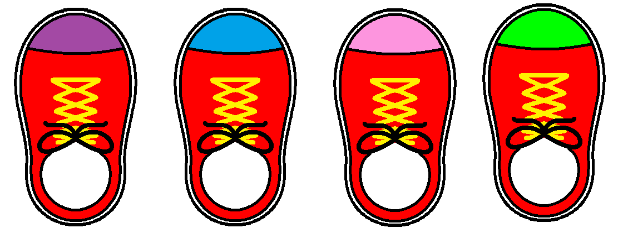Set 1 – All shoes and laces same colour. Different coloured toe caps



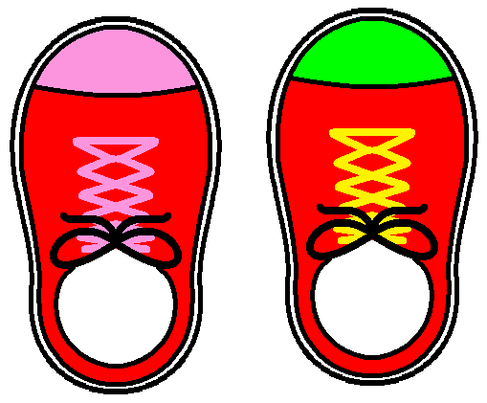Set 2 – Toe caps and land laces same colour.

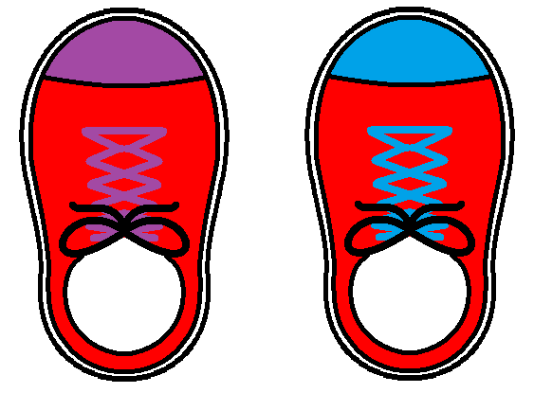

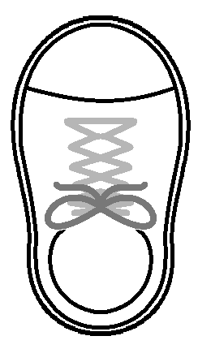**Design your own shoe!**



Write your name here

Colour in /draw your design here

Having footprints over your classroom wall is one way you can display the children’s work

Write your shoe size here





